Name:

PID:

**Due Date: February 1, 2019 at 11:59 PM**

PCB Worksheet

In this worksheet you will create the PCB files for the circuits provided.

Terminology:

|  |  |
| --- | --- |
|  |  |
| Ground | This is the pin that will connect to the GND of Arduino. |
| Signal | This is the pin that is connected to Arduino (D2-D13) or (A0-A5) |
| Power | This is the pin that is connected to wither the 5V or 3.3V of the Arduino |

You must turn in 2 files per problem (.sch and .brd files for each problem). Make sure you use ERC and DRC to check your design for possible errors.

* We will learn more about filters and amplifiers in lab2. For now, let’s just learn how to use Eagle to transform these circuits to PCBs.

1. Create the PCB files for the phootoresistor circuit from lab0 challenge4. Place the screenshot of the schematic and board files in the frames. (3 points)

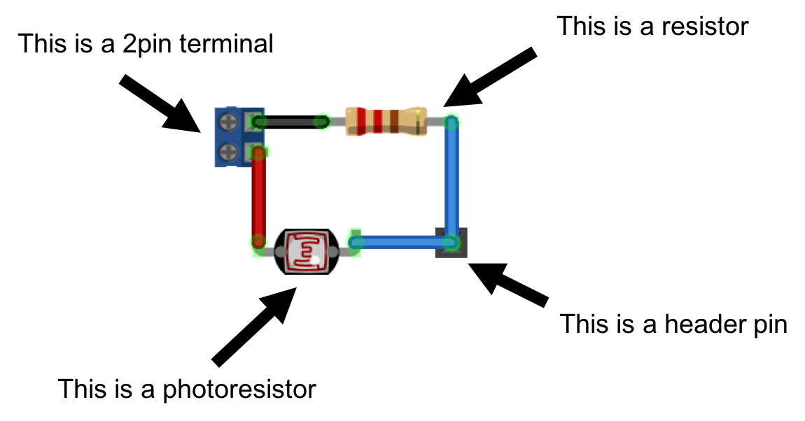

.sch file screenshot goes here

.brd file screenshot goes here

1. Create the PCB files for a voltage divider circuit for a series of photoresistors. Check the diagram of the circuit suited for the PCB design below. Place the screenshot of the schematic and board files in the frames: (4 points)

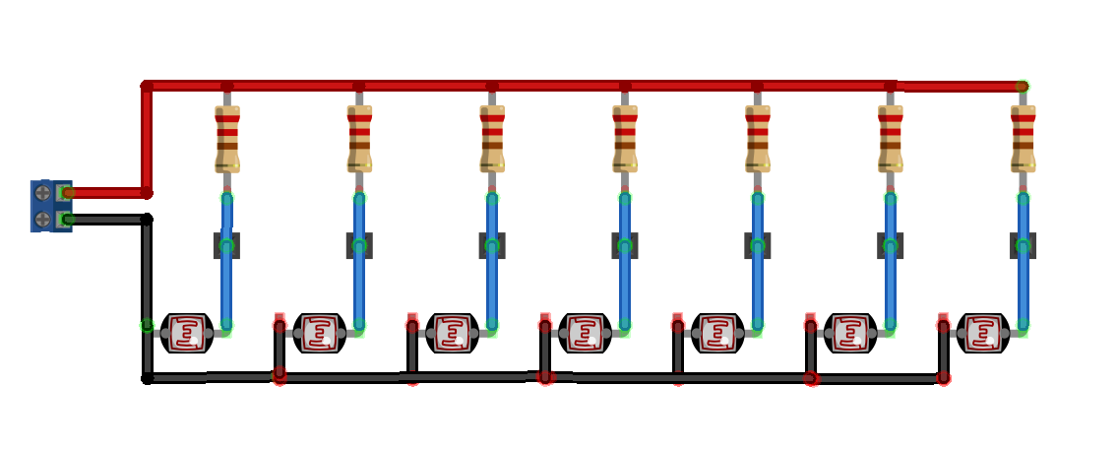

.sch file screenshot goes here

.brd file screenshot goes here

1. Create the PCB files for an amplifier circuit. We will learn more about filters and amplifiers in lab2. Check the diagram of the circuit suited for the PCB design. Place the screenshot of the schematic and board files in the frames: (3 points)

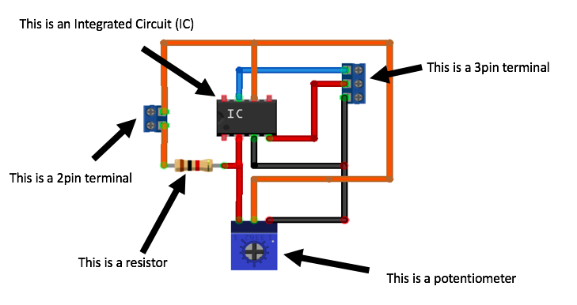

.sch file screenshot goes here

.brd file screenshot goes here

1. Extra credit: Create the PCB files for a low pass filter. Check the *schematic* of the lowpass below. Don’t worry about the values of the parts.(up to 3 points)

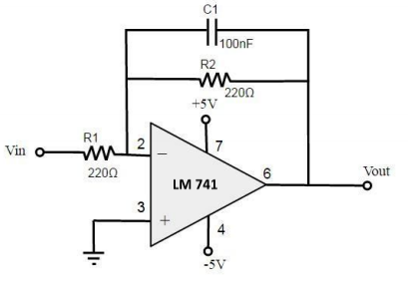

.sch file screenshot goes here

.brd file screenshot goes here

Turn in instructions:

* Zip all the .sch and .brd files for problems 1, 2, 3, 4, and this file (save as .PDF)
* Name the zip file in the following format: LastName_FirstName.zip
  + Example Kafel_Tina.zip for individual report
  + Example Lee_Camille_Shriner_Chloe.zip for a group report
* Submit the zip file on Gradescope.
* Please note the maximum points possible for this worksheet is 10.